**Lab 6 hands on activity - 2D Array**

The purpose of this lab activity is to understand and practice on C++ 2D array.

Problem : Define a two-dimensional array named table large enough to hold the table

of data below. Initialize the array with the values in the table.

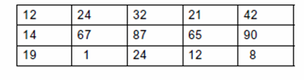

Write a function called display2DArray. The function should accept a two dimensional array as an argument and display its contents on the screen. Consider 2D array given above as a test case example.

Write a function that computes the average value of 2D array for example the table given above.

Lab 7: Hands on Activity -Pointers

The purpose of this lab activity is to understand and practice on C++ pointers and passing function arguments using pointers.

1) pointer to pointers

given:

char ch ='A';

char *p=&ch;

char **q=&p;

char ***r =&q;

print the value of ch using p,q, and r.

2) Function returning pointer

Write a function that gives the smaller of two numbers using the following function declaration.

int * smaller(int *x, in* y);

3) Dynamic memory allocation

Write a C++ program to find sum of N elements entered by user using dynamic memory allocation.